2. Update the **.gitignore** file in such a way that on committing, these files (.log extensions and log folders) are ignored.

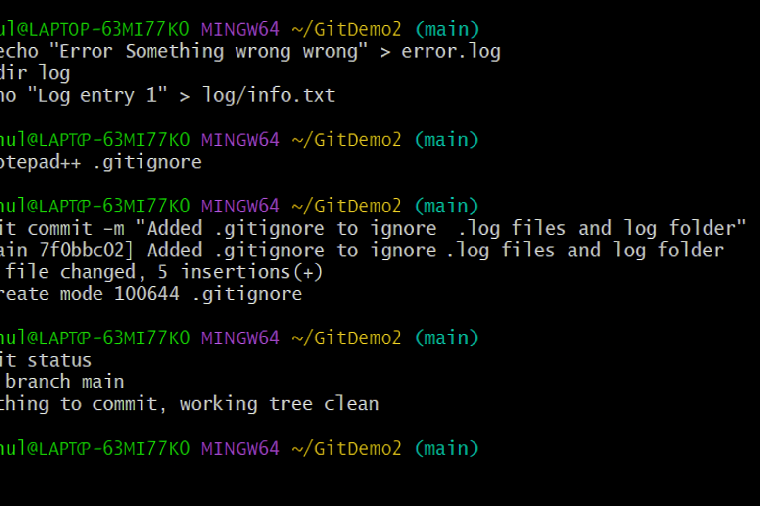v

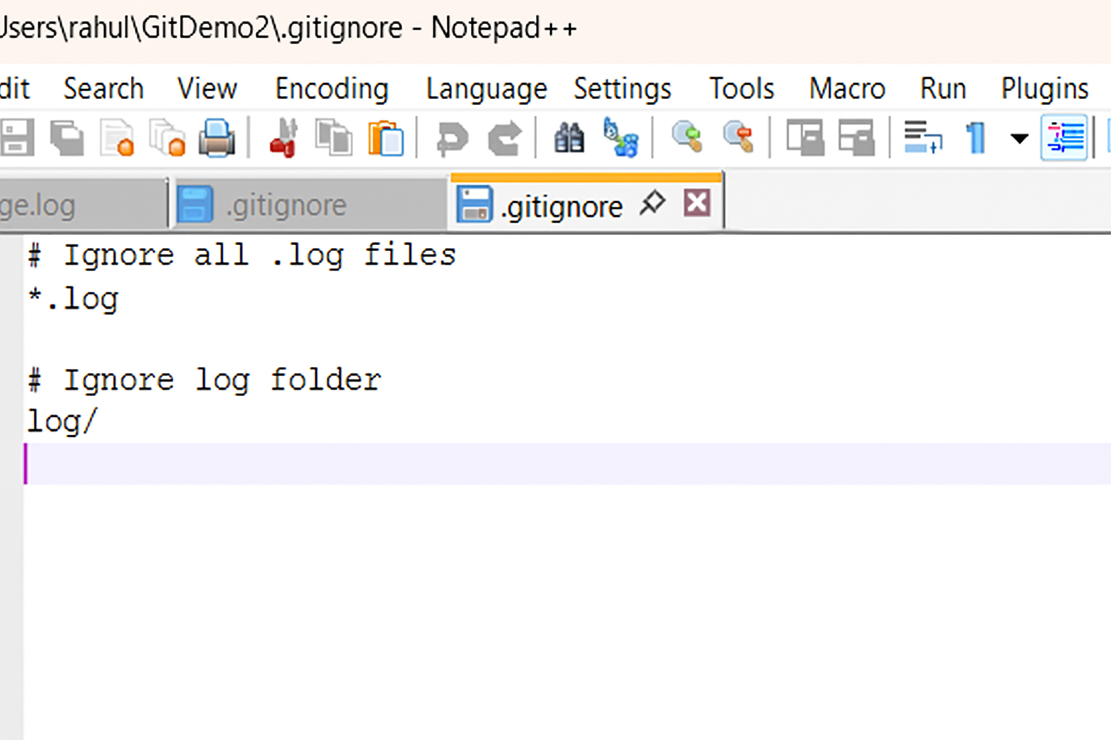

d log folders) are ignored